**Python Coding Challenge 2**

Dataset: **annual-enterprise-survey-2023-financial-year-provisional**

Name: **Harish Er**

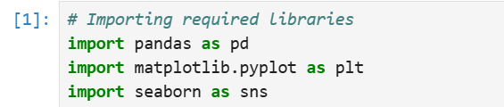



1. **Printing rows of the Data:**

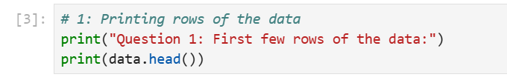

**Output:**

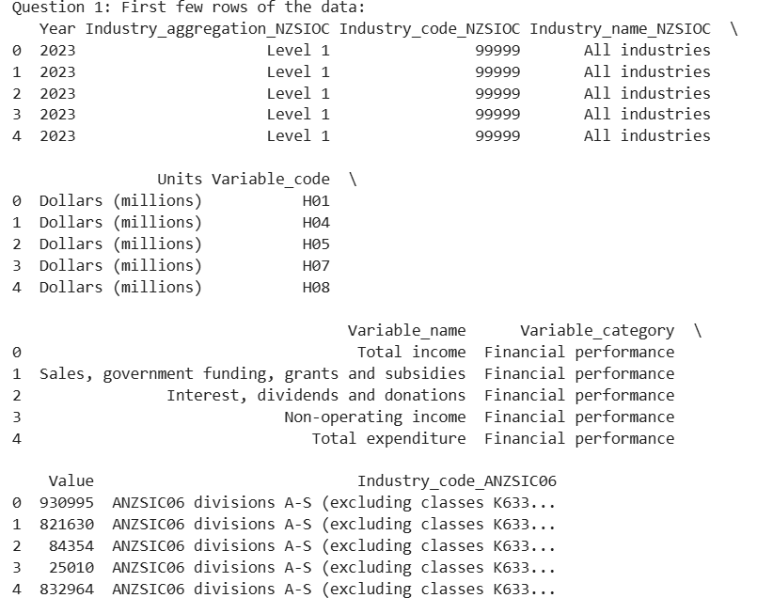

**Explanation:** Preview the first few rows of the dataset using the .head() method.

1. **Printing the column names of the DataFrame:**

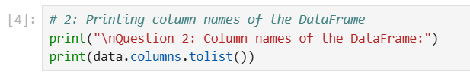

**Output:**



**Explanation:** Retrieve the column names with the .columns attribute.

1. **Summary of Data Frame:**

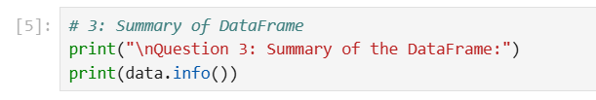

**Output:**

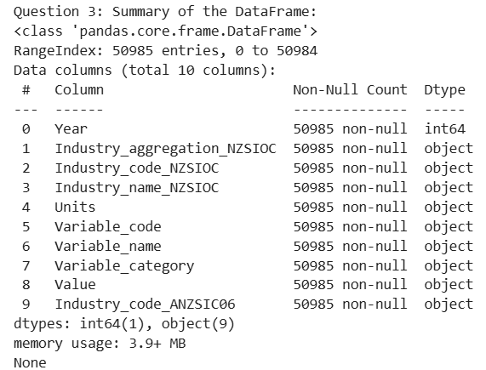

**Explanation:** The .info() method gives an overview of the dataset, including data types and counts of non-null values.

1. **Descriptive Statistical Measures of a DataFrame:**

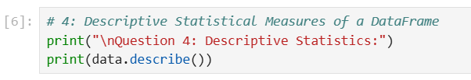

**Output:**

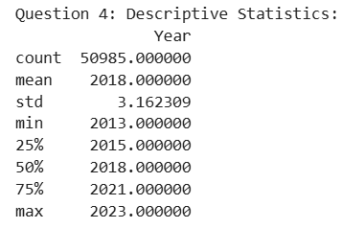

**Explanation:** The .describe() method calculates statistics like mean, standard deviation, and percentiles for numerical columns.

1. **Missing Data Handing:**

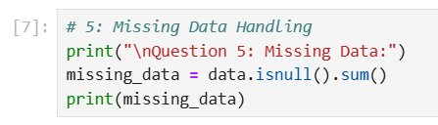

**Output:**

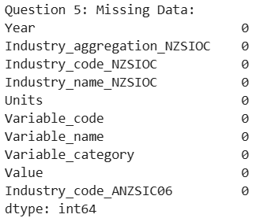

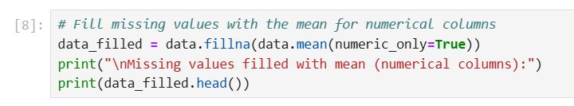

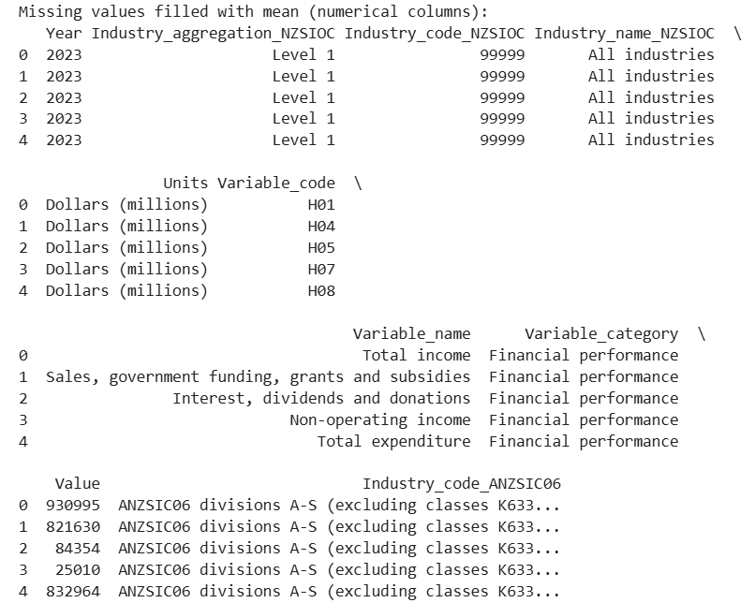

**Explanation:** Missing data can be handled by dropping rows or columns, or by filling missing values with default or computed values (like the mean).

1. **Sorting DataFrame values:**

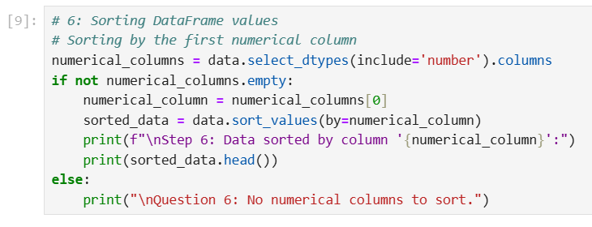

**Output:**

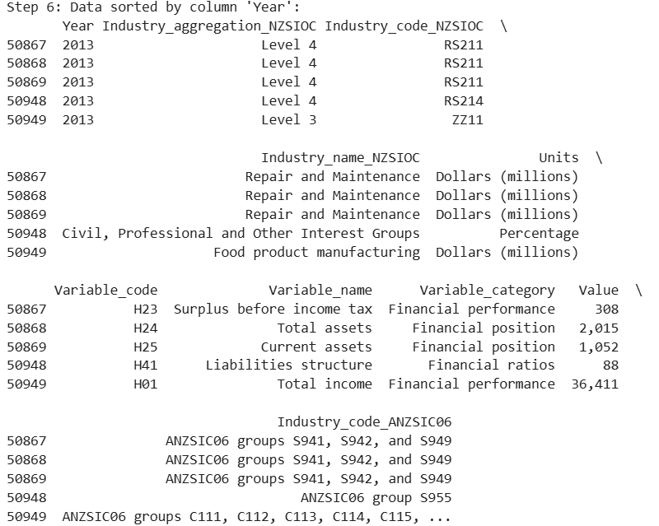

**Explanation:** Data can be sorted by specific columns using the .sort_values() method.

1. **Merge Data Frames:**

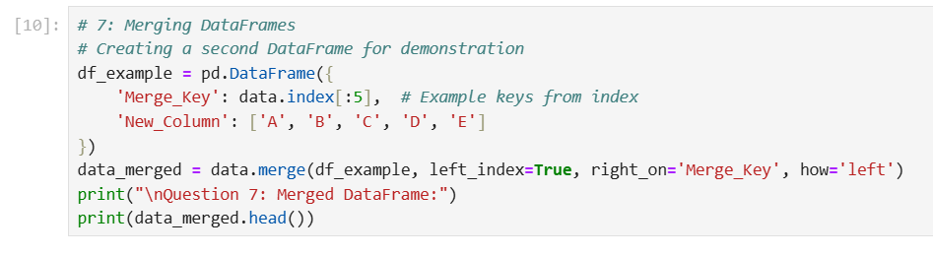

**Output:**

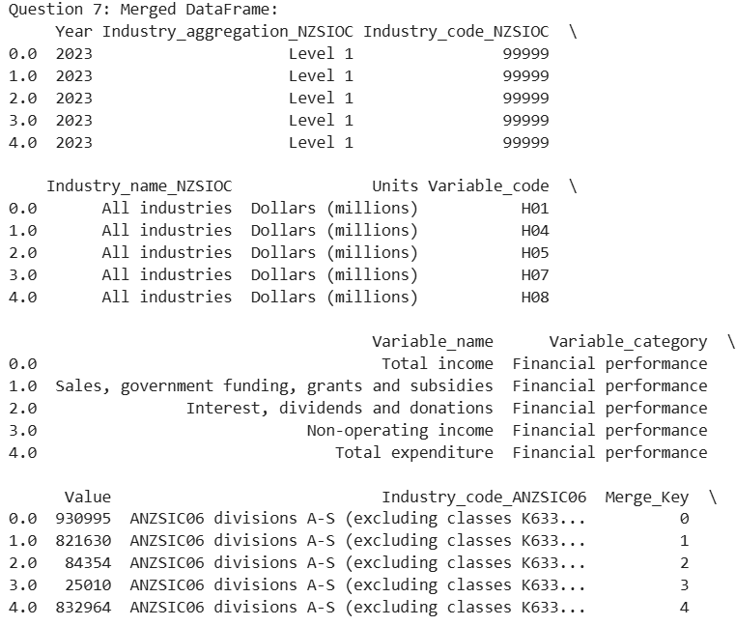

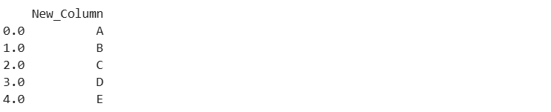

**Explanation:** Created an example of merging two DataFrames based on a common column.

1. **Apply Function:**

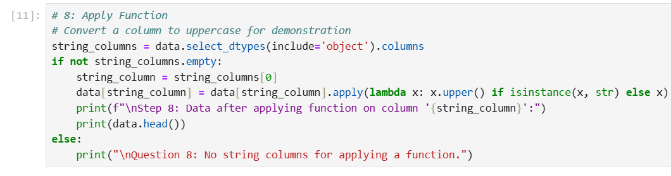

**Output:**

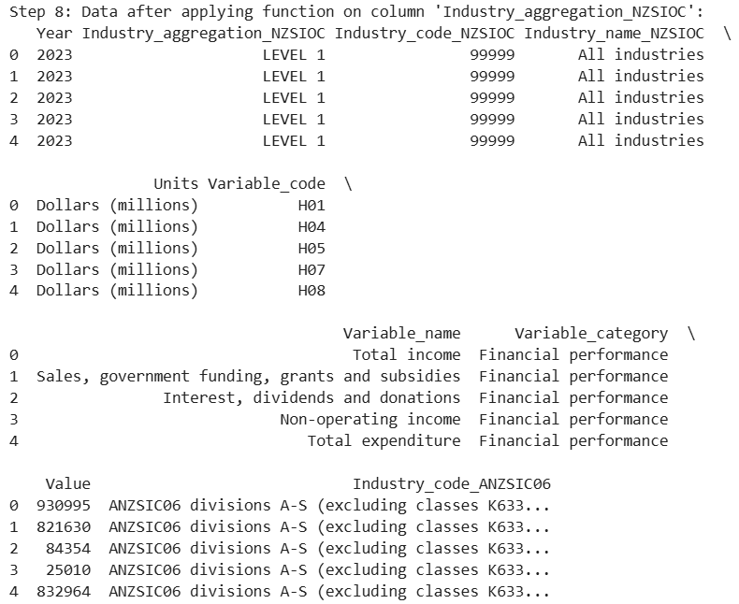

**Explanation:** The .apply() method allows us to apply a function across rows or columns of the DataFrame.

1. **By using the lambda operator:**

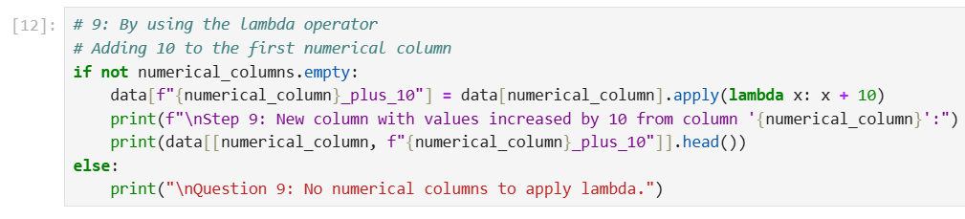

**Output:**

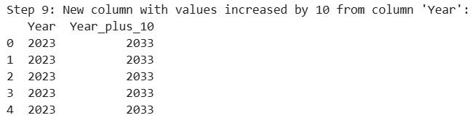

**Explanation:** The lambda operator creates short, anonymous functions that can be applied to DataFrame columns.

1. **Visualizing DataFrame:**

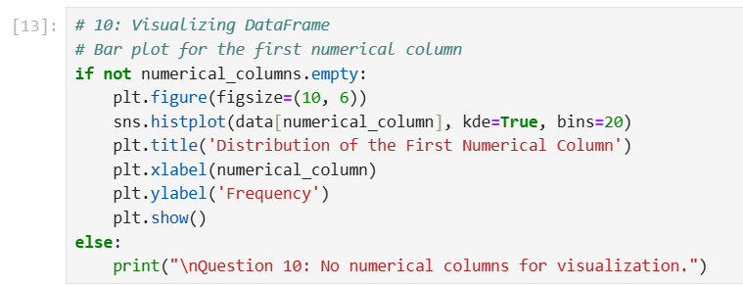

**Output:**

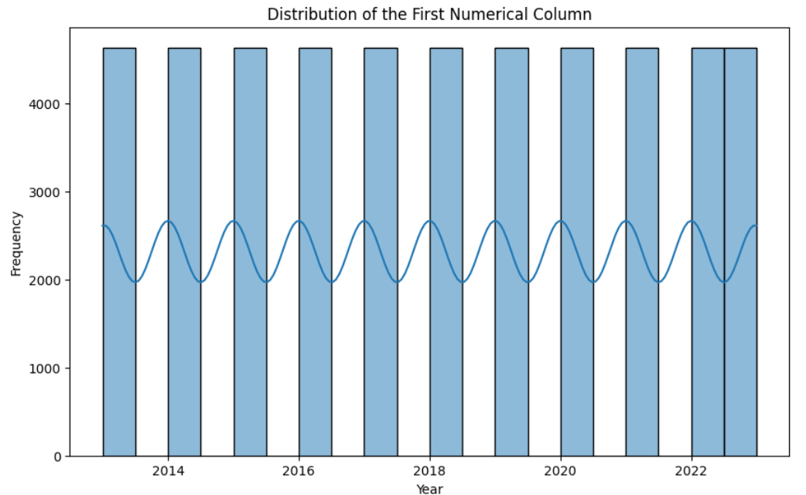

**Explanation:** Visualization helps us understand trends, distributions, and relationships in the data. We'll use libraries like matplotlib or seaborn.

1. **What is the number of columns in the dataset?:**

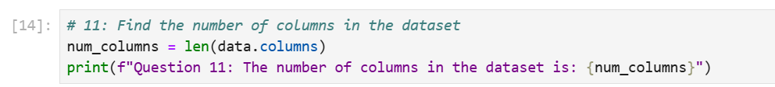

**Output:**



**Explanation:** To determine the number of columns in the dataset, we can use the len() function on the .columns attribute of the DataFrame.